CHORD VARIATIONS
3165 ukulele chords grouped by chord
Asus4
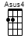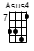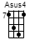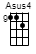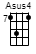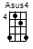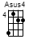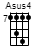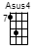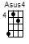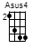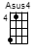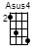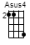
Asus2
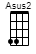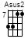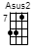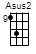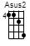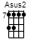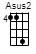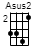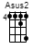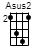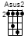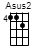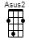
AmM7
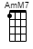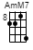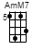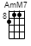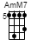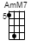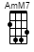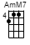
AM7
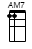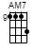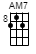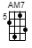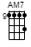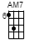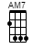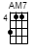
Amadd9
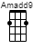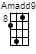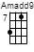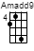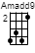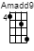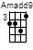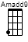
Am7b5
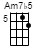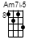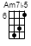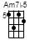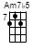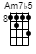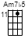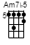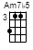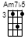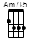
Am7
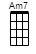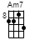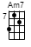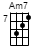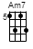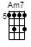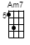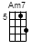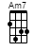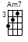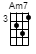
Am6
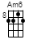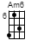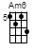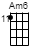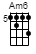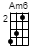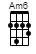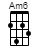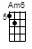
Am+7
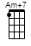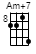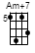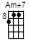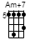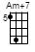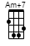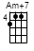
Am
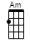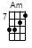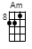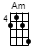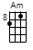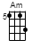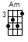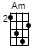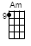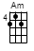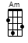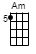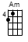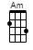

Adim7
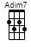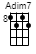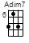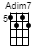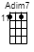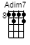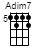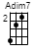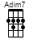
Adim
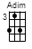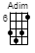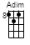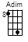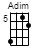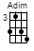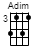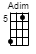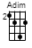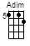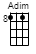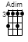
Absus4
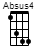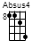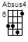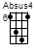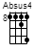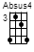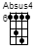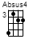
Absus2
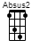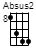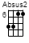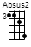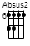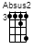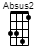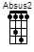
AbmM7
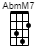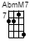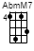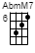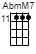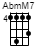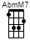
AbM7
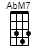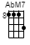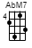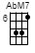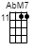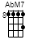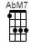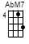
Abmadd9
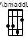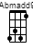
Abm7b5
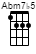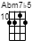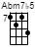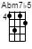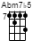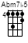
Abm7
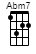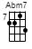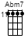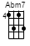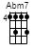
Abm6
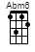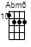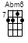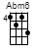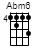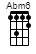
Abm+7
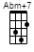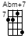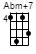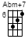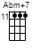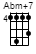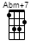

Abm
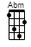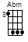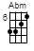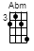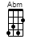
Abdim7
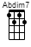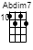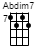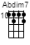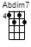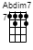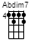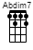
Abdim
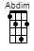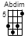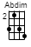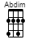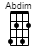
Abaug7
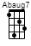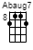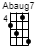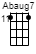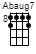
Abadd9
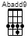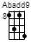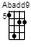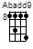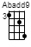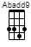
Ab9
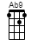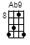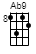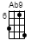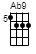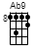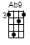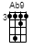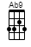
Ab7sus4
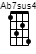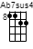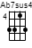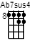
Ab7sus2
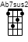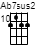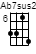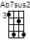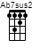
Ab7(no5)
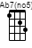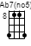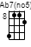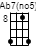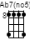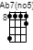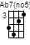
Ab7b5
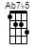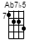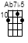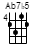
Ab7+5
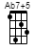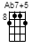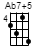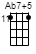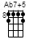

Ab7
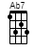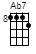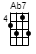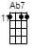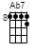
Ab6
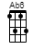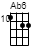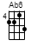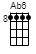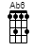
Ab5
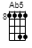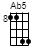
Abaug
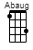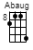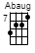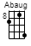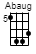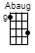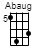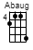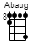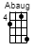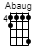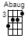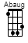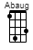
Ab
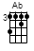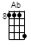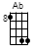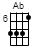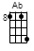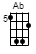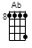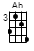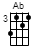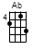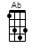
Aaug7
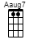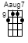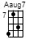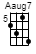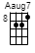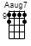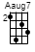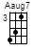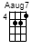
Aadd9
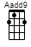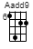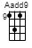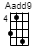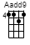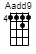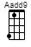
A9
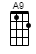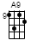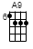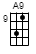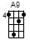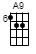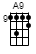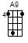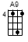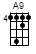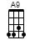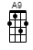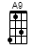
A7sus4
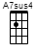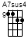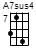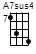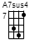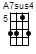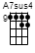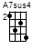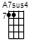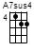
A7sus2
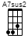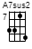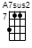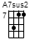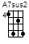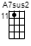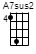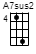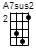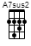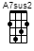
A7(no5)
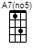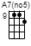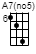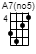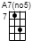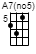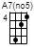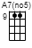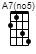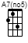

A7b5
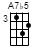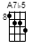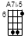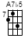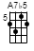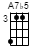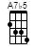
A7+5
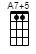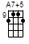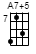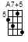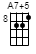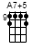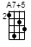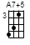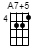
A7
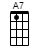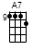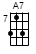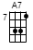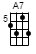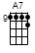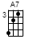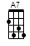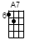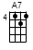
A6
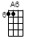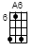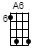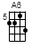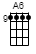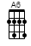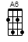
A5
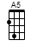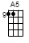
Aaug
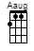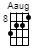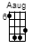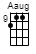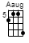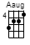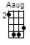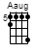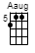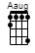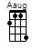
A
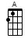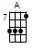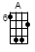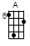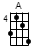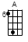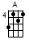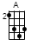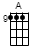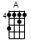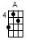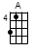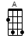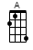
A#sus4
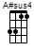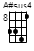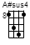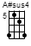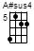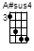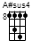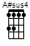
A#sus2
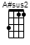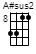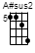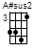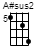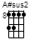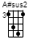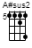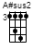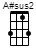
A#mM7
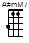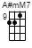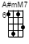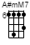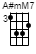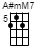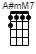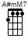
A#M7
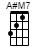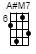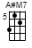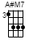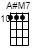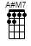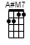

A#madd9
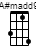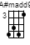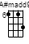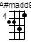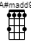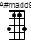
A#m7b5
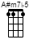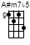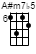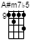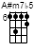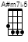
A#m7
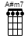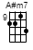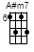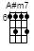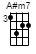
A#m6
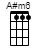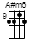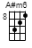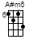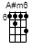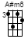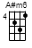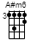
A#m+7
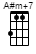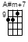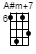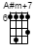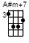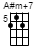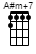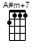
A#m
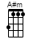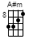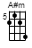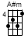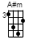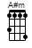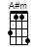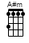
A#dim7
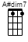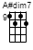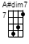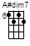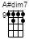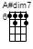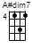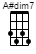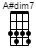
A#dim
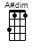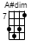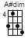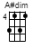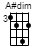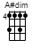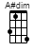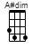
A#aug7
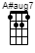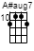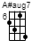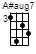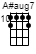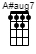
A#add9
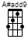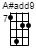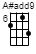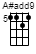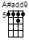
A#9
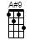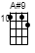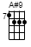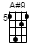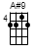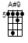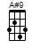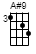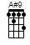

A#7sus4
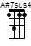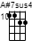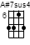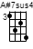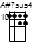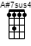
A#7sus2
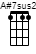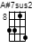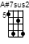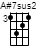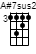
A#7(no5)
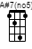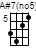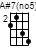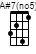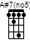
A#7b5
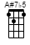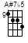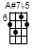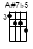
A#7+5
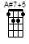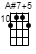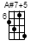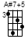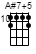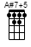
A#7
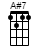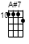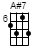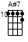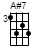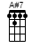
A#6
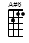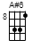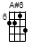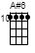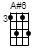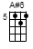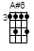
A#aug
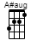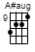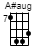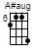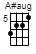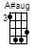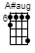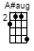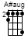
A#
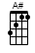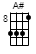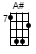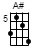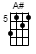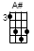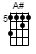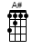
Bsus4
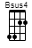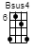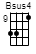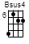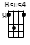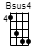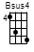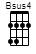
Bsus2
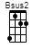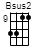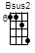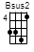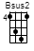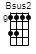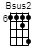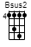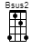

BmM7
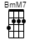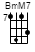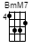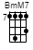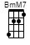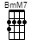
BM7
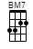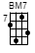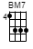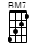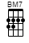
Bmadd9
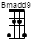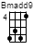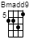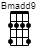
Bm7b5
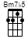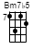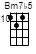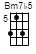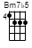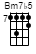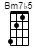
Bm7
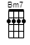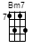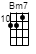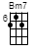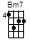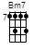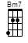
Bm6
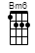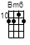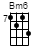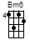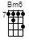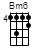
Bm+7
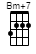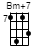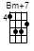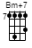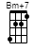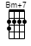
Bm
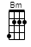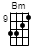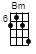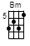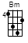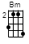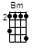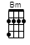
Bdim7
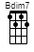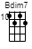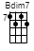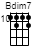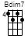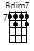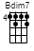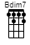
Bdim
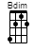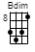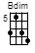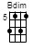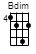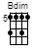
Bbsus4
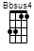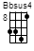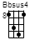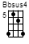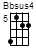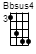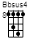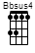

Bbsus2
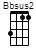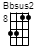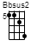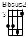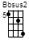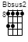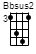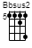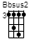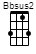
BbmM7
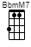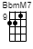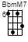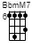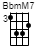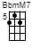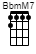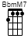
BbM7
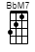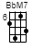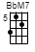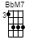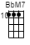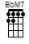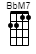
Bbmadd9
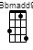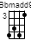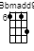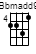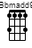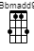
Bbm7b5
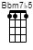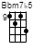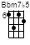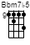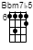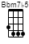
Bbm7
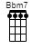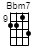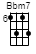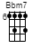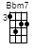
Bbm6
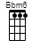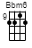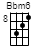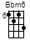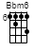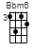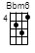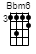
Bbm+7
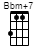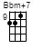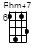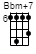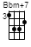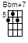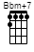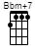
Bbm
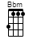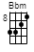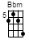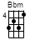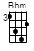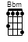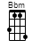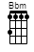
Bbdim7
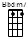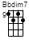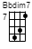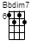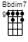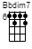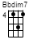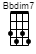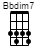
Bbdim
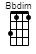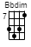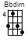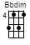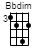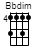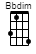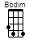

Bbaug7
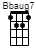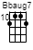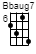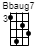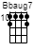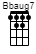
Bbadd9
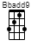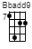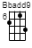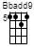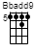
Bb9
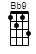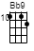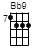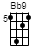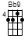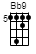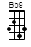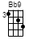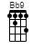
Bb7sus4
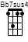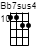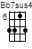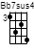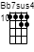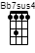
Bb7sus2
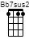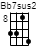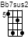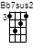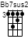
Bb7(no5)
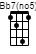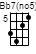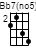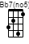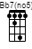
Bb7b5
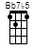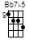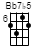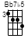
Bb7+5
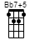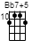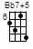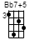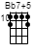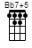
Bb7
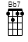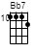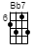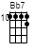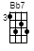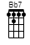
Bb6
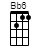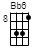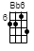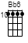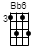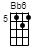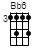
Bbaug
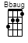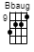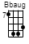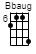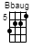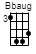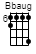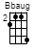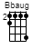

Bb
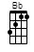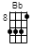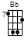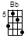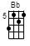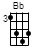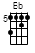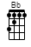
Baug7
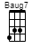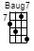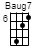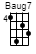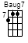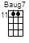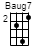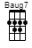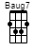
Badd9
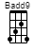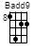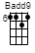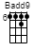
B9
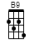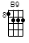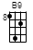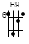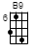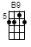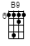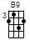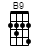
B7sus4
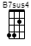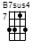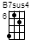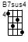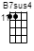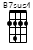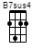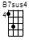
B7sus2
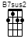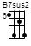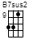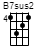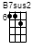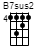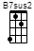
B7(no5)
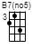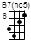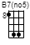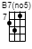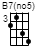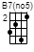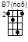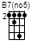
B7b5
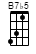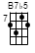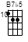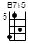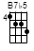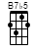
B7+5
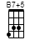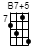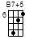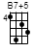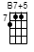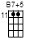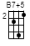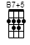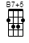
B7
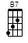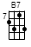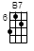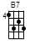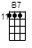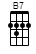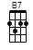
B6
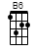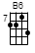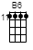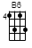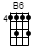

Baug
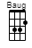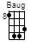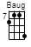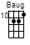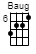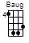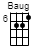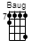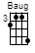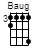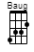
B
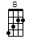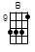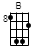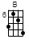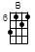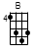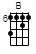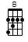
Csus4
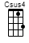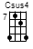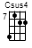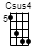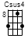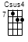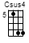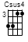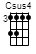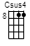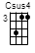
Csus2
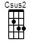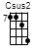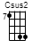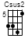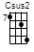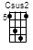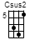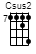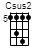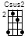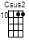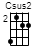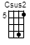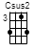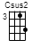
CmM7
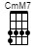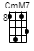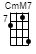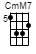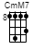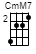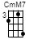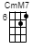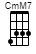
CM7
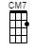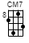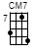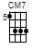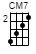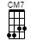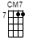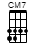
Cmadd9
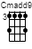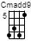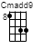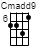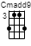
Cm7b5
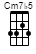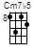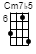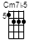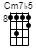
Cm7
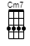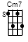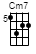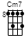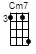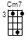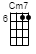
Cm6
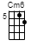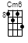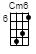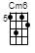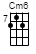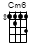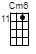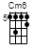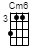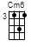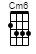

Cm+7
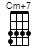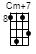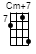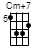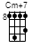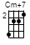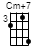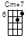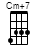
Cm
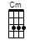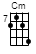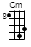
Cdim7
Cdim
Caug7
Cadd9
C9
C7sus4
C7sus2
C7(no5)

C7b5
C7+5
C7
C6
C5
Caug
C
C#sus4
C#sus2
C#mM7

C#M7
C#madd9
C#m7b5
C#m7
C#m6
C#m+7
C#m
C#dim7
C#dim
C#aug7
C#add9

C#9
C#7sus4
C#7sus2
C#7(no5)
C#7b5
C#7+5
C#7
C#6
C#5
C#aug
C#

Dsus4
Dsus2
DnM7
DM7
Dmadd9
Dm7b5
Dm7
Dm6
Dm+7
Dm

Ddim7
Ddim
Dbsus4
Dbsus2
DbmM7
DbM7
Dbmadd9
Dbm7b5
Dbm7
Dbm6
Dbm+7

Dbm
Dbdim7
Dbdim
Dbaug7
Dbadd9
Db9
Db7sus4
Db7sus2
Db7(no5)
Db7b5
Db7+5

Db7
Db6
Db5
Dbaug
Db
Daug7
Dadd9
D9
D7sus4
D7sus2
D7(no5)

D7b5
D7+5
D7
D6
D5
Daug
D
D#sus4
D#sus2
D#nM7
D#M7

D#madd9
D#m7b5
D#m7
D#m6
D#m+7
D#m
D#dim7
D#dim
D#aug7
D#add9
D#9

D#7sus4
D#7sus2
D#7(no5)
D#7b5
D#7+5
D#7
D#6
D#5
D#aug
D#
Esus4

Esus2
EnM7
EM7
Emadd9
Em7b5
Em7
Em6
Em+7
Em
Edim7
Edim

Ebsus4
Ebsus2
EbmM7
EbM7
Ebmadd9
Ebm7b5
Ebm7
Ebm6
Ebm+7
Ebm
Ebdim7

Ebdim
Ebaug7
Ebadd9
Eb9
Eb7sus4
Eb7sus2
Eb7(no5)
Eb7b5
Eb7+5
Eb7
Eb6

Ebaug
Eb
Eaug7
Eadd9
E9
E7sus4
E7sus2
E7(no5)
E7b5
E7+5

E7
E6
E5
Eaug
E
Fsus4
Fsus2
FnM7
FM7
Fmadd9
Fm7b5

Fm7
Fm6
Fm+7
Fm
Fdim7
Fdim
Faug7
Fadd9
F9
F7sus4

F7sus2
F7(no5)
F7b5
F7+5
F7
F6
F5
Faug
F
F#sus4
F#sus2

F#mM7
F#M7
F#madd9
F#m7b5
F#m7
F#m6
F#m+7
F#m
F#dim7
F#dim
F#aug7

F#add9
F#9
F#7sus4
F#7sus2
F#7(no5)
F#7b5
F#7+5
F#7
F#6
F#5
F#aug

F#
Gsus2
Gsus4
GmM7
GM7
Gmadd9
Gm7b5
Gm7
Gm6

Gm+7
Gm
Gdim7
Gdim
Gbsus4
Gbsus2
GbmM7
GbM7
Gbmadd9
Gbm7b5
Gbm7

Gbm6
Gbm+7
Gbm
Gbdim7
Gbdim
Gbaug7
Gbadd9
Gb9
Gb7sus4
Gb7sus2
Gb7(no5)

Gb7b5
Gb7+5
Gb7
Gb6
Gb5
Gbaug
Gb
Gaug7
Gadd9
G9

G7sus4
G7sus2
G7(no5)
G7b5
G7+5
G7
G6
G5
Gaug
G
G#sus4

G#sus2
G#mM7
G#M7
G#madd9
G#m7b5
G#m7
G#m6
G#m+7
G#m
G#dim7
G#dim

G#aug7
G#add9
G#9
G#7sus4
G#7sus2
G#7(no5)
G#7b5
G#7+5
G#7

G#6
G#5
G#aug
G#

