If
David Gates 1971 (as recorded by Bread)

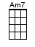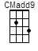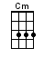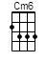or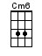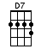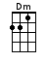

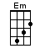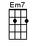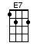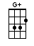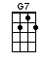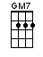

INTRO: / 1 2 3 4 /

[G] / [Gmaj7] / [G7] / [CMadd9] /
[Cm] / [G] / [Cm6] / [D7]↓

If a [G] picture paints a [Gmaj7] thousand words
Then [G7] why can't I paint [C] you
The [Cm] words will never [G] show
The [Cm6] you I've come to [D7] know

If a [G] face could launch a [Gmaj7] thousand ships
Then [G7] where am I to [CMadd9] go
There's [Cm] no one home but [G] you
You're [Cm6] all that's left me [D7] to

And [Em] when my [G+] love
For [Em7] life is running [Am7] dry
You [Dm] come and [E7] pour your-[Am]self on [D7]↓ me

If a [G] man could be two [Gmaj7] places
At one [G7] time I'd be with [C] you
To-[Cm]morrow and to-[G]day
Be-[Cm6]side you all the [D7] way

If the [G] world should stop re-[Gmaj7]volving
Spinning [G7] slowly down to [CMadd9] die
I'd [Cm] spend the end with [G] you
And [Cm6] when the world was [D7] through

Then [Em] one by [G+] one
The [Em7] stars would all go [Am7] out
Then [Dm] you and [E7] I
Would [Am] simply [D7]↓ fly a-[G]way [CMadd9] / [Cm6] / [G]↓

www.bytownukulele.ca

