Stormy Weather
Harold Arlen and Ted Koehler 1933

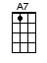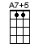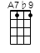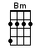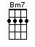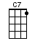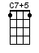or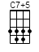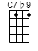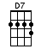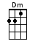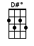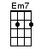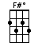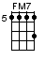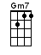or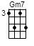

INTRO: / 1 2 3 4 /

[D][Bm7] / [Em7][A7] /
[D][Bm7] / [Em7][A7+5]

Don’t know [D] why [D#dim]
There’s no [Em7] sun up in the [A7] sky
Stormy [D] weather [Bm7]
[Em7] Since my gal and [A7b9] I ain’t to-[D]gether [Bm7]
[Em7] Keeps raining [A7+5] all the [D] time [Bm7] / [Em7][A7+5]

Life is [D] bare [D#dim]
Gloom and [Em7] misery every-[A7]where
Stormy [D] weather [Bm7]
[Em7] Just can’t get my [A7b9] poor self to-[D]gether [Bm7]
[Em7] I’m weary [A7b9] all the [D] time [Bm7]
[Em7] So weary [A7+5] all the [D] time [D7]

BRIDGE:
[G] When she went away, the blues walked [D] in and met me
[G] If she stays away, old rocking [D] chair will get me
[G] All I do is pray the lord a-[D]bove will [Bm] let me
[D] Walk in the [Bm7] sun once [Em7] more, once [C7] more

Can’t go [F] on [F#dim]
Every-[Gm7]thing I had is [C7] gone
Stormy [F] weather [Dm]
[Gm7] Since my gal and [C7b9] I ain’t to-[F]gether [Dm]
[Gm7] Keeps raining [C7+5] all the [F] time [Dm]
[Gm7] Keeps raining [C7+5] all the [Fmaj7]↓ time

www.bytownukulele.ca

