The Twelve Days Of Christmas
The earliest known version of the lyrics was published in London under the title “The Twelve Days of Christmas sung at King Pepin’s Ball”, as part of a 1780 children’s book, Mirth Without Mischief

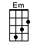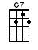
< ~[G]~ means tremolo >

INTRO: / 1 2 3 4 / [C]↓ 2 3

On the [C]↓ first day of Christ-[C]↓mas my [G]↓ true love sent to [C]↓ me -
A [C]↓ partridge [G]↓ in a pear [C]↓ tree [G]↓ [C]↓

On the [C]↓ second day of Christ-[C]↓mas my [G]↓ true love sent to [C]↓ me -
[G]↓ Two turtle-doves
[G]↓ And a [C]↓ partridge [G]↓ in a pear [C]↓ tree [G]↓ [C]↓

On the [C]↓ third day of Christ-[C]↓mas my [G]↓ true love sent to [C]↓ me -
[G]↓ Three French hens
[G]↓ Two turtle-doves
[G]↓ And a [C]↓ partridge [G]↓ in a pear [C]↓ tree [G]↓ [C]↓

On the [C]↓ fourth day of Christ-[C]↓mas my [G]↓ true love sent to [C]↓ me -
[G]↓ Four colly birds
[G]↓ Three French hens
[G]↓ Two turtle-doves
[G]↓ And a [C]↓ partridge [G]↓ in a pear [C]↓ tree [G]↓ [C]↓

On the [C]↓ fifth day of Christ-[C]↓mas my [G]↓ true love sent to [C]↓ me -
[Em]↓ Five [D]↓ gold ~[G]~ rings... [G7]↓
[C]↓ Four colly birds
[F]↓ Three French hens
[G]↓ Two turtle-doves
[G]↓ And a [C]↓ partridge [G]↓ in a pear [C]↓ tree [G]↓ [C]↓

On the [C]↓ sixth day of Christ-[C]↓mas my [G]↓ true love sent to [C]↓ me -
[G]↓ Six geese a-laying
[Em]↓ Five [D]↓ gold ~[G]~ rings... [G7]↓
[C]↓ Four colly birds
[F]↓ Three French hens
[G]↓ Two turtle-doves
[G]↓ And a [C]↓ partridge [G]↓ in a pear [C]↓ tree [G]↓ [C]↓

On the [C]↓ seventh day of Christ-[C]↓mas my [G]↓ true love sent to [C]↓ me -
[G]↓ Seven swans a-swimming
[G]↓ Six geese a-laying
[Em]↓ Five [D]↓ gold ~[G]~ rings... [G7]↓
[C]↓ Four colly birds
[F]↓ Three French hens
[G]↓ Two turtle-doves
[G]↓ And a [C]↓ partridge [G]↓ in a pear [C]↓ tree [G]↓ [C]↓

On the [C]↓ eighth day of Christ-[C]↓mas my [G]↓ true love sent to [C]↓ me -
[G]↓ Eight maids a-milking
[G]↓ Seven swans a-swimming
[G]↓ Six geese a-laying
[Em]↓ Five [D]↓ gold ~[G]~ rings... [G7]↓
[C]↓ Four colly birds
[F]↓ Three French hens
[G]↓ Two turtle-doves
[G]↓ And a [C]↓ partridge [G]↓ in a pear [C]↓ tree [G]↓ [C]↓

On the [C]↓ ninth day of Christ-[C]↓mas my [G]↓ true love sent to [C]↓ me -
[G]↓ Nine drummers drumming
[G]↓ Eight maids a-milking
[G]↓ Seven swans a-swimming
[G]↓ Six geese a-laying
[Em]↓ Five [D]↓ gold ~[G]~ rings... [G7]↓
[C]↓ Four colly birds
[F]↓ Three French hens
[G]↓ Two turtle-doves
[G]↓ And a [C]↓ partridge [G]↓ in a pear [C]↓ tree [G]↓ [C]↓

On the [C]↓ tenth day of Christ-[C]↓mas my [G]↓ true love sent to [C]↓ me -
[G]↓ Ten pipers piping
[G]↓ Nine drummers drumming
[G]↓ Eight maids a-milking
[G]↓ Seven swans a-swimming
[G]↓ Six geese a-laying
[Em]↓ Five [D]↓ gold ~[G]~ rings... [G7]↓
[C]↓ Four colly birds
[F]↓ Three French hens
[G]↓ Two turtle-doves
[G]↓ And a [C]↓ partridge [G]↓ in a pear [C]↓ tree [G]↓ [C]↓

On the e-[C]↓leventh day of Christ-[C]↓mas my [G]↓ true love sent to [C]↓ me -
E-[G]↓leven ladies dancing
[G]↓ Ten pipers piping
[G]↓ Nine drummers drumming
[G]↓ Eight maids a-milking
[G]↓ Seven swans a-swimming
[G]↓ Six geese a-laying
[Em]↓ Five [D]↓ gold ~[G]~ rings... [G7]↓
[C]↓ Four colly birds
[F]↓ Three French hens
[G]↓ Two turtle-doves
[G]↓ And a [C]↓ partridge [G]↓ in a pear [C]↓ tree [G]↓ [C]↓

On the [C]↓ twelfth day of Christ-[C]↓mas my [G]↓ true love sent to [C]↓ me -
[G]↓ Twelve lords a-leaping
E-[G]↓leven ladies dancing
[G]↓ Ten pipers piping
[G]↓ Nine drummers drumming
[G]↓ Eight maids a-milking
[G]↓ Seven swans a-swimming
[G]↓ Six geese a-laying
[Em]↓ Five [D]↓ gold ~[G]~ rings... [G7]↓
[C]↓ Four colly birds
[F]↓ Three French hens
[G]↓ Two turtle-doves
[G]↓ And a [C]↓ partridge [G]↓ in a pear [C]↓ tree [G]↓ [C]↓

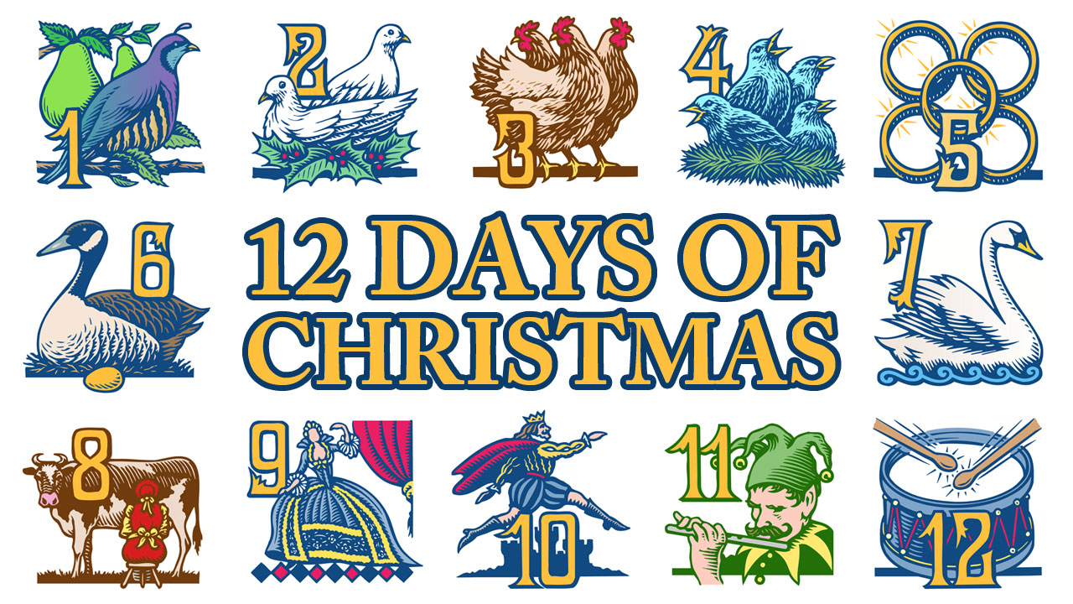

www.bytownukulele.ca

