HOW TO READ TAB

Put together by Sue Rogers, Bytown Ukulele Group, along with some info and photos from a Zing Instruments blog

STRINGS
A tab looks like this. Four horizontal lines representing the strings, with the string names on the left. The G string is the one closest to your chin when you’re playing, the A string is the one closest to the floor when you’re playing.

A |------------|
E |------------|
C |------------|
G |------------|
So imagine the ukulele is laid down on your lap like this:
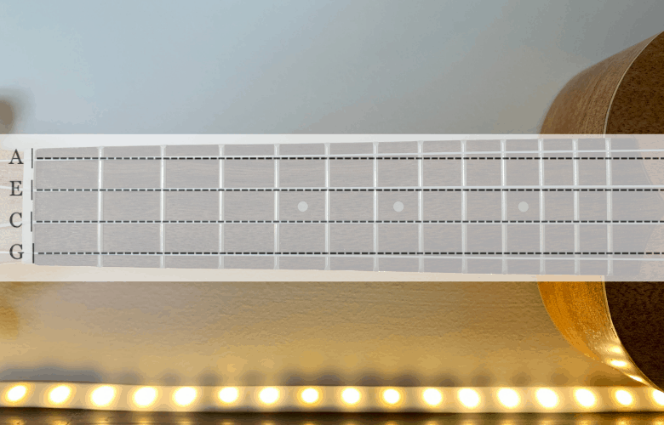

FRETS
So far so good. Now, every time you see a number, it means ‘play this fret’ on this string.

So a 2 here…
A |--2---------|
E |------------|
C |------------|
G |------------|
Means to do this:

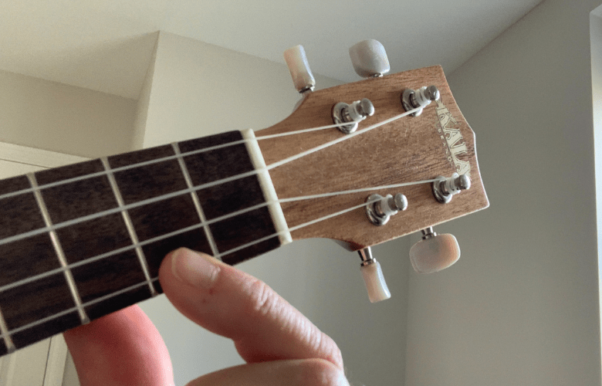

Or a 5 here…
A |------------|
E |------------|
C |--5---------|
G |------------|
means do this:
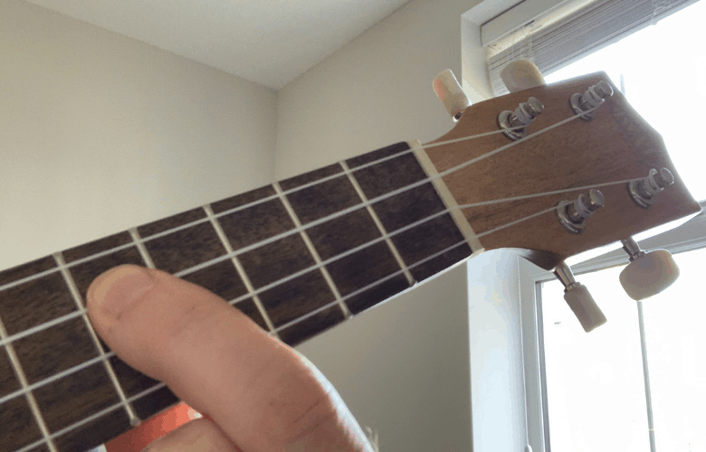

Notice how tab doesn’t tell you which finger to play with, just the fret number you need to play.
Or how about playing the 1st fret multiple times:
A |-1-1-1-1-1-|
E |-----------|
C |-----------|
G |-----------|
Generally, one of the drawbacks to creating tab is depicting rhythm. Some folks who create tab space the fret numbers apart to attempt to show the timing of the notes, as shown below, which isn’t ideal. Whenever I’m creating songsheets for BUG and adding tab, if I have the space I’ll add a count underneath the tab to indicate the rhythm and timing. For example, see our BUG song “Bus Stop” or “Here Comes The Rain Again”.
A |--5---------3-2-----|
E |----------------5-3-|
C |--------------------|
G |--------------------|

CHORDS
Can you show chords in tab? You sure can. If there’s more than one fret number in a vertical line, that often (but not always) means it’s a chord.

For example here is Am, G, C and F:

[Am] [G] [C] [F]
A |--0----2---3---0--|
E |--0----3---0---1--|
C |--0----2---0---0--|
G |--2----0---0---2--|
So that’s all there is to it. Now we’ll look at the common tab symbols used.
TAB SYMBOLS
Tab symbols are used to represent more advanced techniques. Here are the main ones:
Hammer On (h)
A simple ‘h’ is used between two notes to mean hammer on here. In the below example, it’s telling us to hammer-on from the 4th to the 5th fret on the E string.
A |----------|
E |--4h5-----|
C |----------|
G |----------|
Pull Off (p)
And the same in reverse, a ‘p’ means ‘pull off’. So here, it means pull off from the 5th fret to the 4th on the E string.
A |----------|
E |--5p4-----|
C |----------|
G |----------|

Hammer On & Pull Off (^)
Or how about a combination of both. Simply use the ‘^’ symbol for this. So here, it means hammer from the 4th to the 5th fret, and pull off from the 5th back to the 4th fret on the E string.
A |-----------|
E |--4^5^4----|
C |-----------|
G |-----------|
Bend (b)
We all love a bend. Bending is using your chord hand finger to push or pull a string out of its normal alignment, stretching it down or up. As you bend a string, you raise its pitch. To represent this, simply add a ‘b’ in between two notes. Here it means bend from the 4th to the 5th fret on the E string.
A |------------|
E |--4b5-------|
C |------------|
G |------------|
Vibrato (~)
A touch of vibrato, sir? It’s simply shown as a ‘~’ on either side of a note. So below it’s telling you to add vibrato to the 5th fret on the E string.
A |------------|
E |--~5~-------|
C |------------|
G |------------|
Ghost Note ()
Ooh, spooky! Simply add parenthesis around a note to mean ‘play it quietly’.
A |------------|
E |--(5)-------|
C |------------|
G |------------|

Sliding (/ \)
For a slide, use forward-slash (/) for going up the fretboard (towards the soundhole) and backslash (\) for going down. Here it means slide from the 5th fret to the 7th fret on the E string, then slide back down from the 7th to the 5th fret.
A |-------------|
E |---5/7--7\5--|
C |-------------|
G |-------------|
Harmonic (<>)
To play a harmonic on a note, use chevrons. This means play a harmonic at the 12th fret on the E string.
A |-------------|
E |---<12>------|
C |-------------|
G |-------------|

