The Bucket (Riffs)
Kings of Leon 2004 (as performed by Wellington International Ukulele Orchestra)

RIFF 1
An excellent choice of song for any ukulele group: dead easy chords and plenty of widdling for the flash Harrys. Megan’s intro is based on the chords switching between the major and the 5 chord:
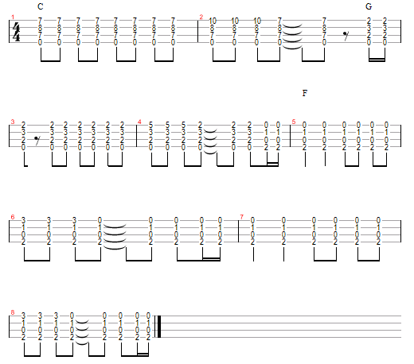
RIFF 2 – see next page
RIFF 3
And there’s the little inbetweeny bit in the chorus:
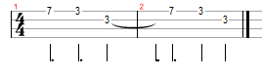
RIFF 4 - TREMOLO
A|7-5-|3---|7-5-|3---|7-5-|3---|7-5-|3---|
E|----|--3-|----|----|----|----|----|----|

A|7-5-|3---|7-5-|3---|7-5-|3---|7-5-|3---|
E|----|----|----|----|----|----|----|----|

RIFF 2
The twiddly bit that comes after that, and crops up a few times in the song, goes like this:
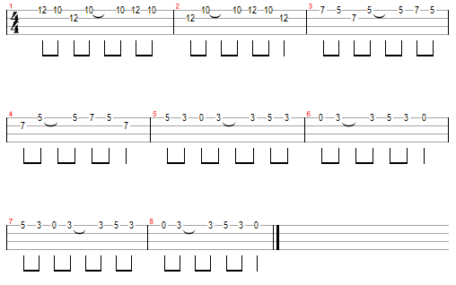
Or, if you want to play it fingerstyle, you can play it like this:
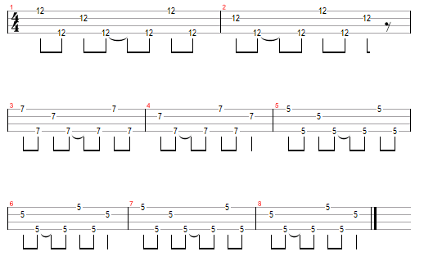
Thanks to Ukulele Hunt for most of the RIFFs!

www.bytownukulele.ca

