What Are You Doing New Year’s Eve?
Frank Loesser 1947 (as performed by Zooey Deschanel and Joseph Gordon-Levitt)

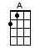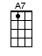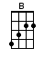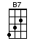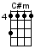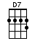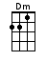
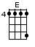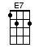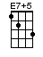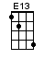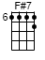or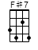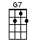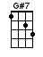

INTRO: / 1 2 3 4 / [A][B7] / [Dm][E7] /

[A] Maybe it's much too [G7] early in the game
[A] Aah, but I [A7] thought I'd [D] ask you just the [Dm] same
[A] What are you [F#7] doin’ [B] New Year's
[E7] New Year's [A] Eve? [B7] / [Dm][E7] /

[A] Who's gonna be the [G7] one who holds you tight
[A] When it's ex-[A7]actly [D] twelve o'clock at [Dm] night
[A] Welcoming [F#7] in the [B] New Year
[E7] New Year's [A] Eve [G#7]

[C#m] Maybe I'm crazy [F#7] to sup-[Am]pose
[C#m] I'd ever be the [F#7] one you [D7] chose
[C#m] Out of a thousand invi-[F#7]tations
[B] You re-[E7+5]ceived

[A] Aah, but in case I [G7] stand one little chance
[A] Here comes the [A7] jackpot [D] question in ad-[Dm]vance
[A] What are you [F#7] doin’ [B] New Year's
[E7] New Year's [A]↓↓ Eve? [Fm]↓↑↓ / [E7]↓↓[E]↓ /
[A]↓ What are you [F#7]↓ doin’ [B]↓ New Year's
[E7]↓ New [E13]↓ Year's [A]↓ Eve?

www.bytownukulele.ca

