Till There Was You
Meredith Willson 1957 (recorded by The Beatles 1963)

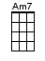and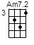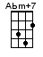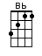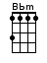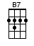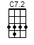and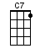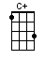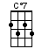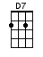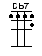

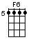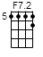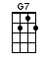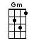

INTRO: / 1 2 3 4 /

[F][Cdim7] / [Gm][C7] /
[F][Cdim7] / [Gm][C7]

There were [F] bells on a [Cdim7] hill
But I [Gm] never heard them [Bbm] ringing
No I [F] never [Am7]² heard them [AbmM7] at [Gm] all
[C7] Till there was [F] you / [Gm][C7]

There were [F] birds in the [Cdim7] sky
But I [Gm] never saw them [Bbm] winging
No I [F] never [Am7]² saw them [AbmM7] at [Gm] all
[C7] Till there was [F] you / [F7]²

Then there was [Bb] music [Bbm] and wonderful [F] roses
They’d [D7] tell me, in [Gm] sweet fragrant [G7] meadows
Of [C7] dawn, and [Caug] dew

There was [F] love all a-[Cdim7]round
But I [Gm] never heard it [Bbm] singing
No I [F] never [Am7]² heard it [AbmM7] at [Gm] all
[C7] Till there was [F] you / [Gm][C7]

INSTRUMENTAL:
There was [F] love all a-[Cdim7]round
But I [Gm] never heard it [Bbm] singing
No I [F] never [Am7]² heard it [AbmM7] at [Gm] all
[C7] Till there was [F] you / [F7]²

Then there was [Bb] music [Bbm] and wonderful [F] roses
They’d [D7] tell me, in [Gm] sweet fragrant [G7] meadows
Of [C7] dawn, and [Caug] dew

There was [F] love all a-[Cdim7]round
But I [Gm] never heard it [Bbm] singing
No I [F] never [Am7]² heard it [AbmM7] at [Gm] all
[C7] Till there was [F] you / [F] /
[C7]² Ti-[B7]-i-[C7]²-ill, there was [F] you / [Db7] / [F] / [F6]↓ [Am7]↓

www.bytownukulele.ca

