A Marshmallow World
Carl Sigman, Peter De Rose 1949

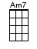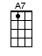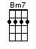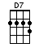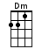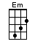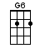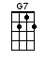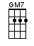

INTRO: / 1 2 3 4

In [A7] winter, it's a [D] marshmallow [G] world [D7]↓

It's a [G] marshmallow [GM7] world in the [G6] winter [GM7]
When the [G] snow comes to [GM7] cover the [D] ground [D7]
It's the [Am7] time for [D7] play, it's a [G] whipped-cream [Em] day
I [A7] wait for it the whole year [D] round [D7]

Those are [G] marshmallow [GM7] clouds being [G6] friendly [GM7]
In the [G] arms of the [GM7] evergreen [D] trees [D7]
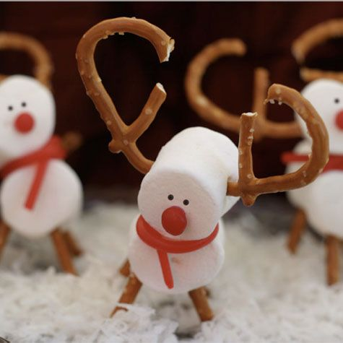
And the [Am7] sun is [D7] red, like a [G] pumpkin [Em] head
It's [A7] shining so your [D] nose won't [G] freeze

The [G7] world is your snowball [C] see how it [Am] grows
[Dm] That's how it [G7] goes, when-[C]ever it snows
The [A7] world is your snowball [D] just for a [Bm7] song
Get [A7]↓ out, and [A7]↓ roll it a-[D]long [D7]↓

It's a [G] yum-yummy [GM7] world made for [G6] sweethearts [GM7]
Take a [G] walk with your [GM7] favourite [D] girl [D7]
It's a [Am7] sugar [D7] date, what if [G] spring is [Em] late?
In [A7] winter, it's a [D] marshmallow [G] world [D]↓

It's a [G] marshmallow [GM7] day in the [G6] winter [GM7]
When the [G] snow comes to [GM7] cover the [D] ground [D7]
It's the [Am7] time for [D7] play, it's a [G] whipped-cream [Em] day
And we [A7] wait for it the whole year [D] round (Just you re-[D7]member that)

Those are [G] marshmallow [GM7] clouds being [G6] friendly [GM7]
In the [G] arms of the [GM7] evergreen [D] trees [D7]
And the [Am7] sun is [D7] red, like a [G] pumpkin [Em] head
It's [A7] shining so your [D] nose won't [G]↓ freeze (You must remember that)

The [G7] world is your snowball [C] see how it [Am] grows
[Dm] That's how it [G7] goes, when-[C]ever it snows
The [A7] world is your snowball [D] just for a [Bm7] song
Get [A7]↓ out, and [A7]↓ roll it a-[D]long [D7]↓

It's a [G] yum-yummy [GM7] world made for [G6] sweethearts [GM7]
Take a [G] walk with your [GM7] favourite [D] girl [D7]
It's a [Am7] sugar [D7] date, what if [G] spring is [Em] late?
In [A7] winter, it's a [D] marshmallow [G] world
In [A7] winter, it's a [D] marshmallow [G] world
In [A7] winter…, it's a [D] marsh…mallow [G] world [G]↓[D]↓[G]↓

www.bytownukulele.ca

