Have Yourself A Merry Little Christmas
Hugh Martin & Ralph Blane 1944

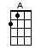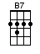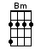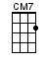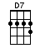
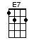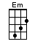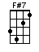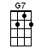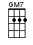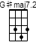

INTRO: / 1 2 3 4 /

[G][Em] / [Am][D7] /

[G] Have your-[Em]self a [Am] merry little [D7] Christmas
[G] Let your [Em] heart be [Am] light [D7]
[G] Next year [Em] all our [C] troubles
Will be [D7] out of [B7] sight [E7] / [Am][D7] /

[G] Have your-[Em]self a [Am] merry little [D7] Christmas
[G] Make the [Em] Yule-tide [Am] gay [D7]
[G] Next year [Em] all our [Am] troubles
Will be [B7] miles a-[Em]way [G7]

[Cmaj7] Once again as in [Bm] olden days [A]
Happy [Am] golden days [D] of [Gmaj7] yore
[Em] Faithful [F#7] friends who were [Bm] dear to us
Will be [D7] near to us [A] once [D] more [D7]

[G] Someday [Em] soon we [Am] all will be to-[D7]gether
[G] If the [Em] fates al-[Am]low [D]
[G] Until [Em] then we’ll [Am] have to
Muddle [B7] through some [Em] how [G7]
So [C] have yourself
A [Am] merry little [D7] Christmas / [G]↓ now [G]↓[G#maj7]↓[G#maj7]↓ / [G]↓

www.bytownukulele.ca

